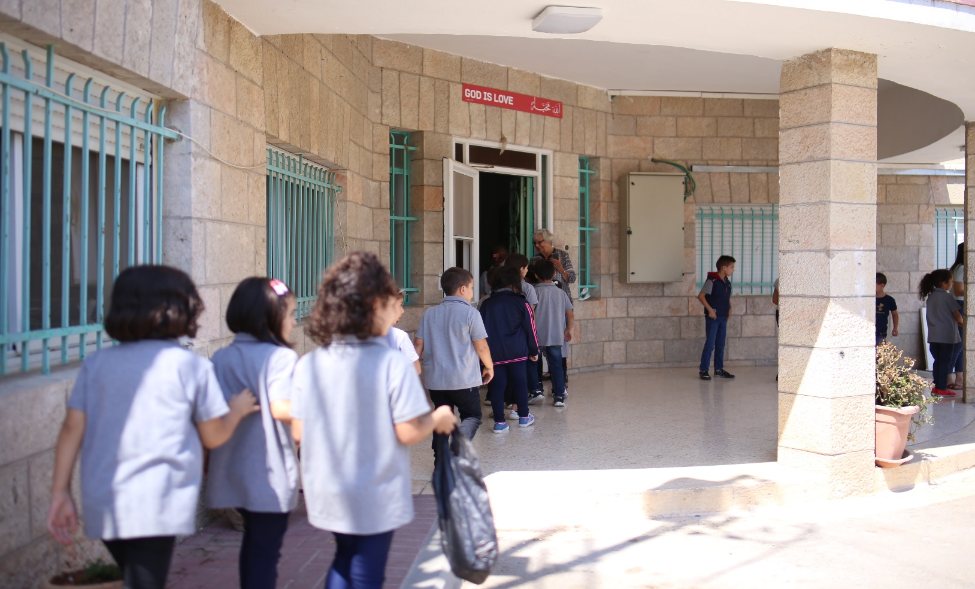

*October 2019*

**Hope School**

NEWSLETTER

A whole month has flown by and we could not be more grateful for how the school year has started. The students and teachers alike have settled into their school routines, and though the school days feel ‘normal’ by now, the everyday reality that we are able to do what we do; to offer a hopeful future for our students, is a joy that doesn’t go away.

Reflecting on the school year so far, teachers have noticed a shift in the classroom atmosphere this year compared to the last. Classrooms are calmer, and teachers note that students are getting more out of every lesson. This, they note, comes both out of conflict resolution workshops for teachers, as well as not admitting more students in each class than they can handle.

Something we’ve been most excited about this fall is witnessing the great personal and academic achievements of a number of our students. Some that struggled in their studies at their previous schools are beginning to thrive at Hope School. Students that were not performing or behaving well in past years at our school have improved in both areas immensely. In recognition of their improvement, the school decided to award 5 students every month during the morning Chapel. Kamel (one of the awarded students in September) had 19 warnings, 5 fails at his previous school and was dismissed from there. Now he has been certified as one of the best students, performing wonderfully academically (second at the class) and behaviorally. His father contacted the school and extended his sincere gratitude for the remarkable and swift progress at his only child’s educational career. “Amazing… my child is back. Thank you very much… I know he will succeed at Hope School” as he quoted.

We want to continue to empower student initiative, and so we had elected student representatives from each class meet to discuss school-wide activities they want to implement this year. One idea that the students were most enthusiastic about was putting on marathon for the schools in the Beit Jala area! We think this is a great idea.

Thank-you for your continued partnership with us in providing hope for so many lives. Again we will say, we could not do what we do without you! Your support is positively shaping the future of our community’s young people.

Blessings,

The director, staff and students at Hope School.

HIGHLIGHTS

(Below) After a month of having Yvonne Turner at Hope School, we were sad to say goodbye. We are so grateful for how much she has invested into this school and the lives of our students, especially that of the boarders. She has faithfully been visiting and supporting Hope School for over 10 years!

(Middle) Farah, one of the five award recipients for her great improvement and hard work.

(Above) This is Rida, one of our new boarders, reciting a poem he wrote about friendship during chapel.

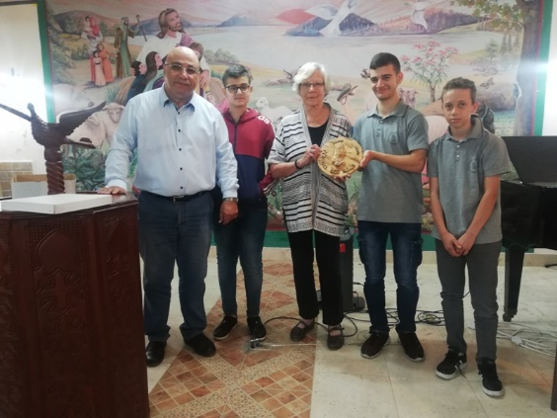

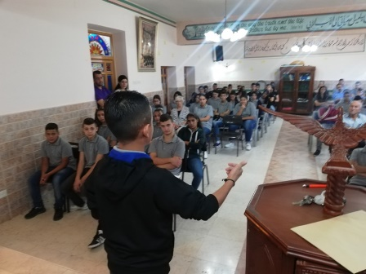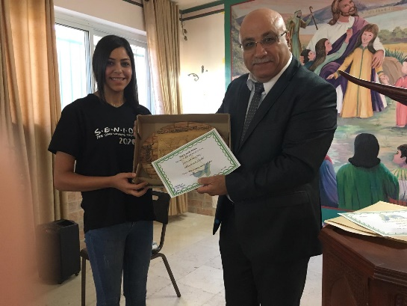

Email: [info@hopeschoolpal.com](mailto:info@hopeschoolpal.com) website: [www.hopesschoolbeitjala.com](http://www.hopesschoolbeitjala.com) tel: 00972-2-2742268