HOPE SECONDARY SCHOOL
P.O. Box 19208, Jerusalem, Israel
Email:info@hopeschoolpal.com
www.hopeschoolbeitjala.com
Sponsor a Child at Hope School
Every year concerned international donors make it possible for children living in The Holy Land to attend Hope School.
Without sponsorship these children would end up on the streets, forgotten in large government classes, or unable to attend school at all because their parents cannot afford basic requirements like food, books and uniforms.
Hope School Child Sponsorship Program offers you a chance to make a meaningful difference in the life of a child.
What could be closer to God’s heart?
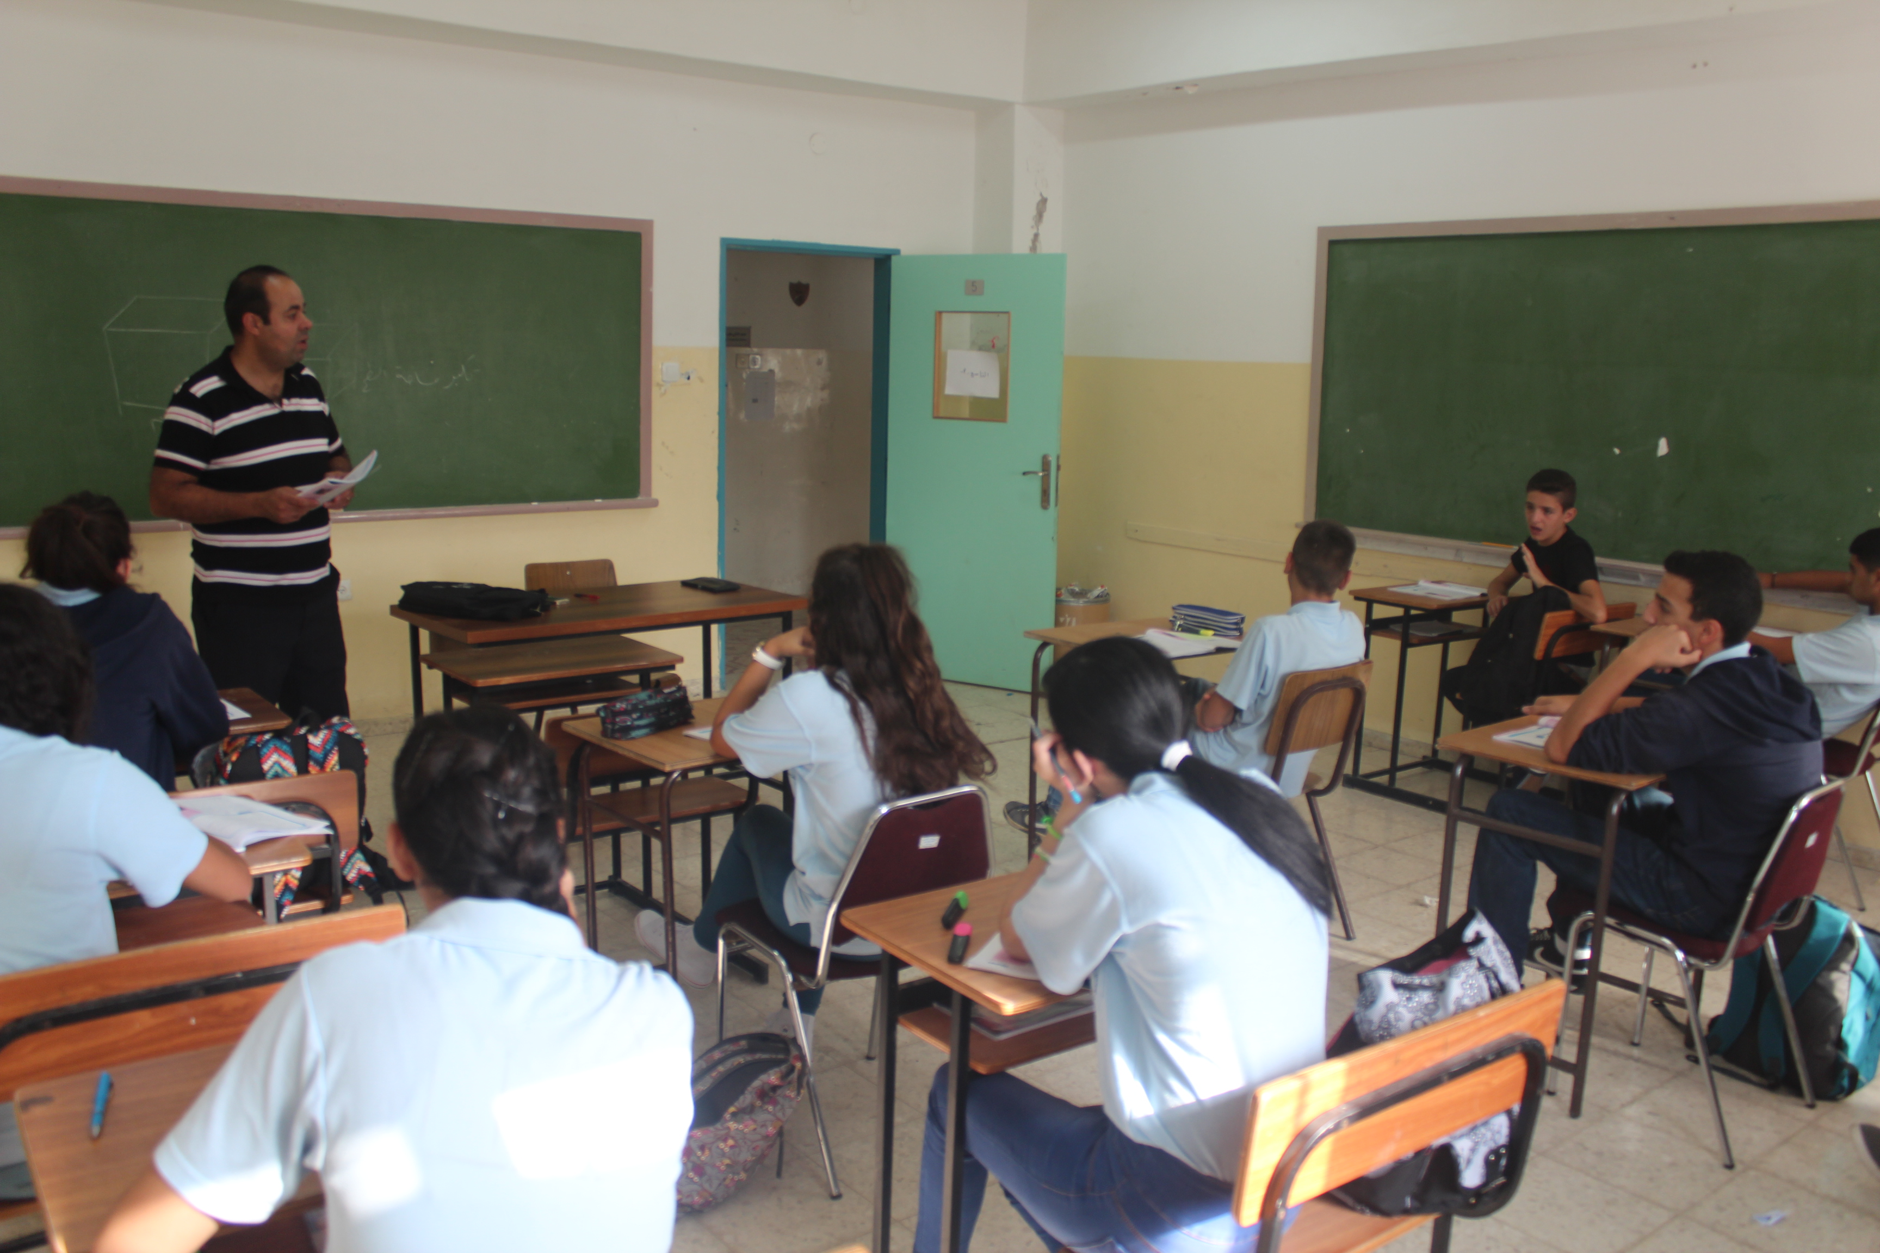
Your support changes every aspect of your sponsored child’s life. Children at Hope School have the opportunity to thrive spiritually, academically, socially and physically. Hope School was founded in 1962 and through a holistic, long-term approach, it is committed to helping children in desperate need grow into educated, fulfilled adults.
When you sponsor a child at Hope School with encouraging letters and financial donations, you help end the cycle of poverty. You change their world, giving them hope and a new beginning.

How it works
The first step is to contact the school office at info@hopeschoolpal.com to receive information about the children, ages 11-17, with sponsorship needs. Hope School Child Sponsorship Program aims to support 100 students in each school year.
The program pairs a child with a sponsor parent for a minimum of one year and a maximum of six years. Following the first year, sponsors are requested to renew their funding for subsequent years. A child is selected by the school’s administration for sponsorship if one or more of the following circumstances apply:
- only one parent takes care of the child,
- one of the parents is chronically ill or disabled,
- the parents have more than 6 children,
- the child needs extra help because of health problems, learning disabilities etc.,
- the parents have demonstrable economic problems,
- the child is an orphan
What is the need?
Hope School is a private school and receives no government subsidies. It costs $4300 per year to provide a child in the boarding section with education, food, and communal living in a supervised dormitory. To educate a day student, it costs $3500 per year. We ask sponsors to cover a fraction of the cost. While any contribution is welcome, we hope you will make a commitment of:
$2000 to sponsor a boarding student;
$1000 to sponsor a day student.
Sponsorship changes lives of children—and their sponsors.
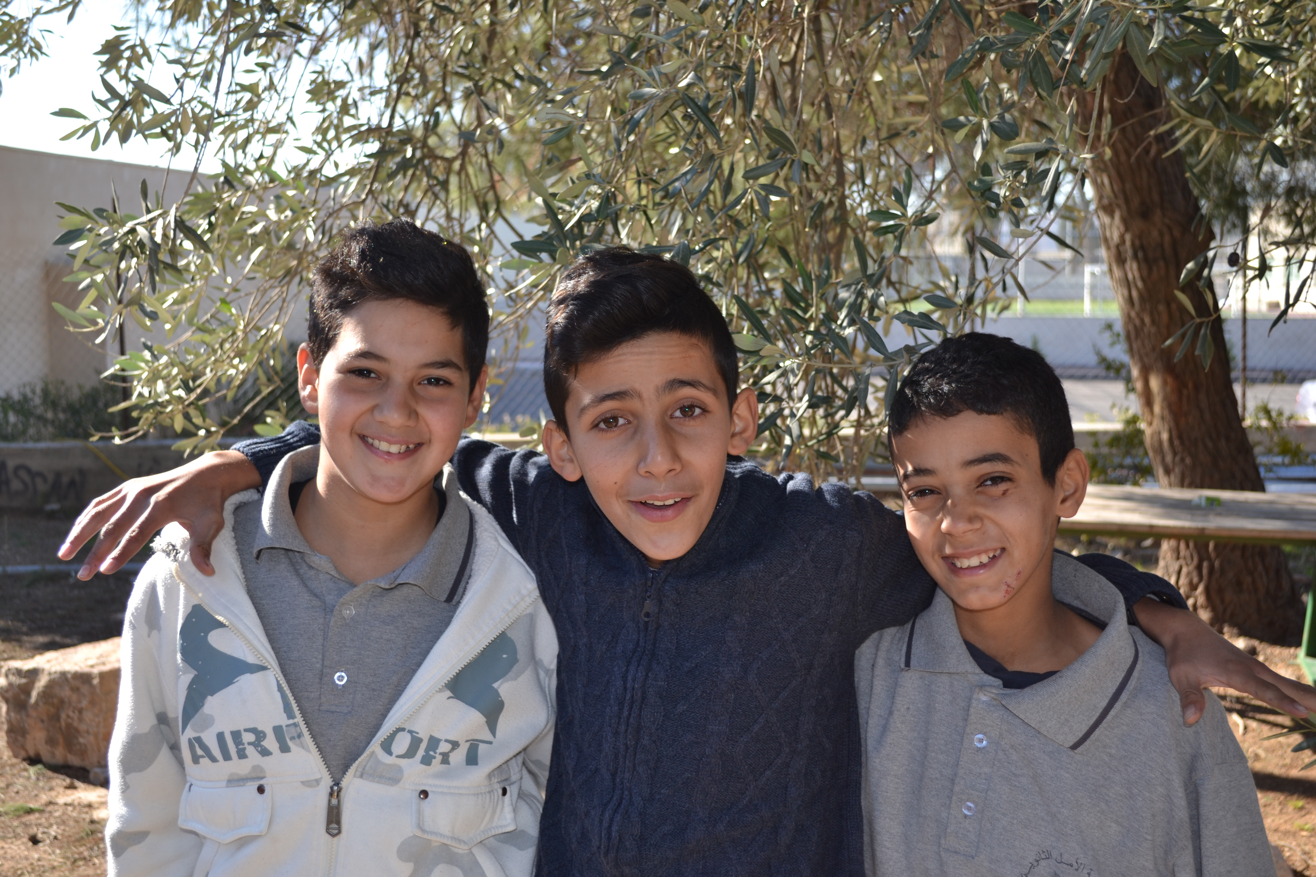
The sponsorship program has flourished over the years thanks to hundreds of concerned individuals like yourselves. Your gifts directly contribute to the child’s basic needs at school: quality education, books and materials; and in the boarding section, clean water, healthy food, and a quiet and safe community in which to live and study.
Sponsors also develop a relationship with a child that is powerful and unique. For any category of sponsorship you will receive an annual update by mail including a picture, a letter from the child, and his or her report book. As you exchange letters, send photos and offer encouragement in Jesus' name, your love will bring hope to a child that will last a lifetime.
Please contact the Hope School Sponsorship Coordinator, Mrs. Laila Nour, to be guided through the process today! info@hopeschoolpal.com


During the period of your sponsorship, you are of course free to contact Laila as much as you like to get in touch with your sponsored child. You will also receive updates on your sponsored child’s development as well as the development of Hope School at the end of each term of the school year.
Second, you should decide if you would rather donate your money monthly or as a one-off donation. Details for donating can be found at www.hopesschoolbeitjala.com/donations. If you decide to transfer your money monthly, you should arrange with your bank an automatic transfer every month. Hope School will take care of contacting you in order to make sure that your money has reached our bank.
Thirdly, you will be inspired and encouraged for years to come!
If you have made your decision, send an e-mail requesting to sponsor a child. Hope School will send you the complete information about the sponsor child.
Please do not hesitate to contact us at: info@hopeschoolpal.com
Welcome to child sponsorship!
You’ve said YES to sponsor a child.
Thank you for making room in your heart for a precious child.
Sponsorship money will help fund education. Your gifts will provide books, materials and teachers so your child can learn, grow and achieve more. And you also help fund other initiatives at our boarding section, such as healthy food, clean water for drinking and a healthy environment to live and study in.
You’ll see the multiple ways your kindness makes a difference for a precious child you know by name, and whom you will grow to love.
Ultimately, sponsorship is an exciting exploration for both your child and for you. Congratulations on beginning this new adventure.

